**UNIVERSITY OF ZAGREB**

**FACULTY OF ORGANIZATION AND INFORMATICS**

**VARAŽDIN**

**Marko Bartolić,** [**mbartoli@foi.hr**](mailto:mbartoli@foi.hr)

**Rene Škuljević,** [**rskuljev@foi.hr**](mailto:rskuljev@foi.hr)

**Tomislav Vunak,** [**tvunak@foi.hr**](mailto:tvunak@foi.hr)

**NAVIGATION ON A SKI SLOPE**

**PROJECT DOCUMENTATION FOR SOFTWARE ANALYSIS AND DEVELOPMENT PROJECT**

**Varaždin, 2016.**

**UNIVERSITY OF ZAGREB**

**FACULTY OF ORGANIZATION AND INFORMATICS**

**VARAŽDIN**

**Team number:** T10

**Team members:**

Marko Bartolić, 0016092146

Rene Škuljević, 0016092375

Tomislav Vunak, 0016091502

**NAVIGATION ON A SKI SLOPE**

**PROJECT DOCUMENTATION FOR SOFTWARE ANALYSIS AND DEVELOPMENT PROJECT**

**Mentors:**

Doc. dr. sc. Zlatko Stapić

Ivan Švogor, mag.inf.

**Evolaris mentors:**

Gerald Binder

Thomas Rößler

**Varaždin, 2016.**

**Table of contents**

1. Introduction 4

2. Software development methodology 5

2.1. Scrum team 5

2.2 Sprint 1 6

# Introduction

We are developing a mobile application for the Evolaris company. They had already worked on similar application for navigation on ski slope. We are going to develop a software which will focus on a more fulfilling user experience while skiing. Our main goal is to implement the algorithm for navigation on a ski track. Evolaris will provide us with the existing part of their application. We will implement new algorithm for calculating if the skier is on the right course and where should he turn next.

Evolaris is Austrian company founded in 2000 and is based in Graz. Their primary focus rests on the conception and development of digital assistance systems in the industrial and commerce sector. They guarantee individual solutions with a unique user experience. Also they are very proud on their efficient and attractive interfaces that enable end users to make the best use of information, which adds value for businesses. In addition to that, they advise companies in their selection of suitable technologies, design individual application scenarios and develop assistance systems on the basis of mobile and wearable technologies.

The purpose of this application is to help the skier determine if he is skiing on the track and to alert him if he leaves the track. Also, the application will calculate the position of the skier on the track and when he approaches a junction on the track, notify him about which turn he should take.

We were given the Recon Snow2 ski goggles for testing purposes for our application. Also Evolaris provided us with their web server and database which are used for storing information about tracks.

Recon Snow2 are ski goggles from Canadian company Recon Instruments. They produce smart glasses and heads-up displays for sports.

Application code and project documentation will be stored in our public GitHub repository <https://github.com/rskuljev/Navigation-on-a-ski-slope/> .

This document contains information about software development methodology and how we implemented it in our project. Other than this document, the project characteristics are explained in technical documentation.

# Software development methodology

For the development of this project we are going to use agile software development methodology. There are few agile methodologies, like Scrum, Extreme Programming, etc. Since the requirement of our mentors is to use Scrum, that is what we will be using.

Scrum methodology has demands and boundaries which we need to respect. First one is having a Scrum master, a person who will ensure that team achieves all sprint goals. In our team Scrum master needs to be part of the development team, and will be responsible for delivering appropriate project documentation on time. We have three iterations, but not all of them are the same length, mostly because we depend on availability of information that we received from Evolaris company and deadlines determined by our mentors.

The tools we chose to accomplish this task include Android Studio and Java programming language for the application itself. The tracking algorithm was first implemented in C# using Visual Studio, but was later rewritten in Java. As for the implementation of Scrum, we discovered and used beta web application called Taiga.io which can be accessed here <https://tree.taiga.io/project/mbartoli-navigation-on-a-ski-slope/> .

Scrum methodology has so far helped us in organizing our time better and giving and tracking responsibility to all team members. We have two main problems to solve in this project. One is determining if the skier has left the track and the other is showing the appropriate arrow in which direction the skier should turn while arriving at junction. In first iteration our goal is to discuss and agree on functionalities of the application, implement the main menu and prepare everything for future implementations. In second iteration we have to focus on implementing the tracking algorithm in C# (which will later be rewritten in Java) and to solve the problem of tracking the course on a ski track. Finally, in third iteration we have to translate the tracking algorithm in Java, connect with Evolaris’ web server and show the appropriate arrow on the display when the skier arrives at junction.

## Scrum team

Our Scrum team consists of three roles, which are Product Owner, Scrum Master and Development team. We assigned roles to all team members and every team member has responsibilities which depend on their assigned role. Still, as our mentors requested, each team member will be working on the development of the application.

|  |  |  |
| --- | --- | --- |
| Product owner | Scrum Master | Development Team |
| Gerald Binder  Evolaris company | Marko Bartolić | Rene Škuljević  Tomislav Vunak |

## Product backlog

Product backlog is a list of work that should be done by the development team. Items in the product backlog are defined by product owner, but the Scrum Master sorts them into sprints depending on their importance. Our product backlog was refactored a few times because it took some time until we finally agreed what Evolaris demands from us and what we can do. Product backlog for this project is shown in figure 2.

Sprint one began on 12th October 2015 and ends on 27th October 2015. It has 35 completed points and 8 tasks. Since Sprint 1 started before our final agreement, during this first sprint we focused on basic functionalities of the application, which can be seen in figure X.

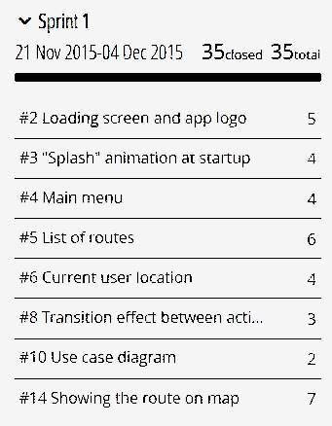

*Figure 1. Tasks in sprint 1*

Performance of the development team can be analyzed by using burndown charts. The gray line shown on the graph represents the ideal distribution of finishing tasks. The green line shows the actual work done by the development team. If the green line is above the gray one, it means that the development team is behind schedule and the project is late. Contrary, if the green line is below the gray one, it means that the project is ahead of schedule. Sprint 1 burndown chart of our project can be seen in figure X, and it shows that throughout the whole sprint the project was a bit late.

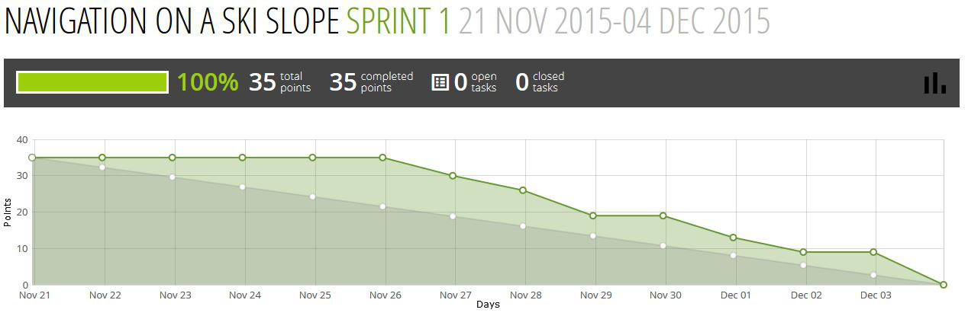

*Figure 2. Sprint 1 burndown chart*